## Front End Engineering-II

Project Report

Semester-IV (Batch-2022)

Template(59)



**Supervised By: Submitted By:**

Raveesh samkaria Suhavi jindal

2210990867

G-13

**Department of Computer Science and Engineering**

## Chitkara University Institute of Engineering & Technology,

## Chitkara University, Punjab

**Table of content:**

|  |  |  |
| --- | --- | --- |
| **s.no** | **content** | **Page no.** |
| **1** | **Introduction** | **1** |
| **2** | **Objectives** | **1** |
| **3** | **Technology used** | **1-2** |
| **4** | **Project Breakpoints** | **2-3** |
| **5** | **File structure** | **3** |
| **6** | **Code** | **4-8** |
| **7** | **Conclusion** | **8** |
| **8** | **Result** | **9-12** |
| **9** | **Future Enhancements** | **12** |
| **10** | **References** | **12-13** |

### Introduction

This project involves the creation of a modern, responsive agency template website using Tailwind CSS and React. The primary goal is to develop a user-friendly, aesthetically pleasing website that showcases the services, portfolio, and team members of a digital agency. Tailwind CSS is chosen for its utility-first approach, which allows for rapid styling, while React provides a powerful framework for building interactive user interfaces.

### Objectives

1. **Design an attractive and functional layout**: The website should have a professional look and feel, with a layout that highlights the agency's offerings effectively.
2. **Ensure responsiveness**: The site must be fully responsive, providing an optimal user experience across various devices and screen sizes.
3. **Implement interactive elements**: Use React to create dynamic components such as a service showcase, portfolio gallery, and team member profiles.
4. **Optimize performance**: Ensure fast load times and smooth navigation to enhance user experience.

### Technologies Used

1. **React**: A JavaScript library for building user interfaces, chosen for its component-based architecture and efficiency.
2. **Tailwind CSS**: A utility-first CSS framework that allows for rapid styling and customization.
3. **JavaScript (ES6+)**: For the core scripting of React components and functionality.
4. **HTML5 & CSS3**: For the basic structure and styling of the web pages.
5. **Node.js and npm**: For managing dependencies and running development scripts.

### Project Breakdown

#### 1. Initial Setup

* **Create React App**: Used Create React App to initialize the project, setting up a standard React development environment.
* **Install Tailwind CSS**: Integrated Tailwind CSS by installing it via npm and configuring the **tailwind.config.js** file.

#### 2. Layout and Design

* **Header Component**: Designed a responsive navigation bar with links to different sections of the site.
* **Hero Section**: Created an eye-catching hero section with a background image, a headline, and a call-to-action button.
* **Services Section**: Displayed a list of services using cards that highlight key features and benefits.
* **Profile Section**: Developed a dynamic gallery to showcase completed projects, using React hooks to manage state.
* **Blog Section**: Introduced team members with profile cards including images, names, roles, and social media links.
* **Footer Component**: Implemented a footer with contact information, social media links, and additional navigation.

#### 3. Interactive Elements

* **Service Cards**: Added hover effects and transitions to make the service cards interactive.
* **Portfolio Filtering**: Implemented filtering functionality to allow users to sort projects by category.
* **Modal Pop-Ups**: Created modal pop-ups for detailed views of portfolio items.
* **Form Handling**: Developed a contact form with validation and submission handling using React state and event management.

#### 4. Performance Optimization

* **Code Splitting**: Implemented code splitting using React's lazy and Suspense to improve load times.
* **Image Optimization**: Used responsive images and lazy loading to enhance performance.
* **Minification and Compression**: Ensured that CSS and JavaScript files are minified and compressed for faster delivery.

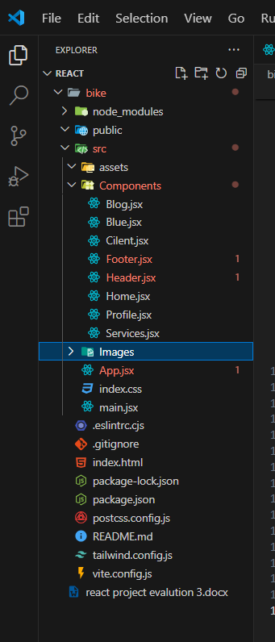**File structure**:

**Code:**

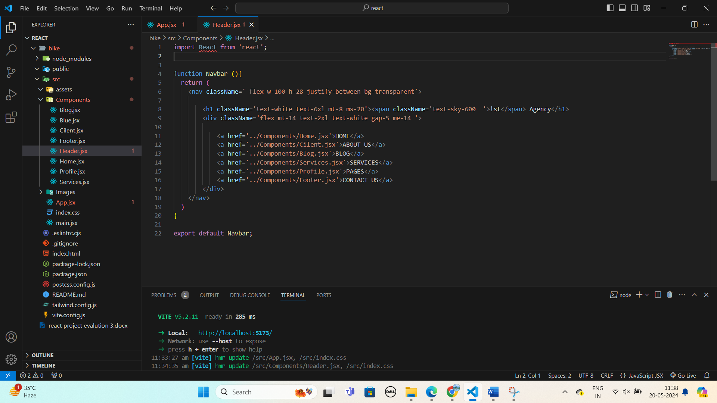

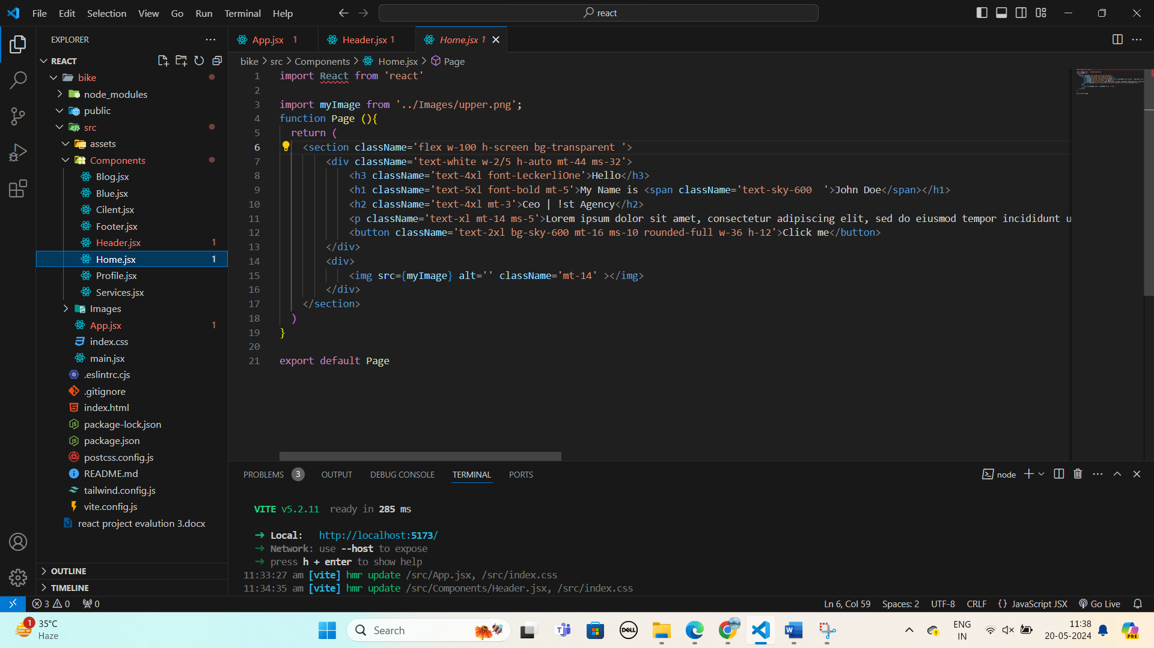

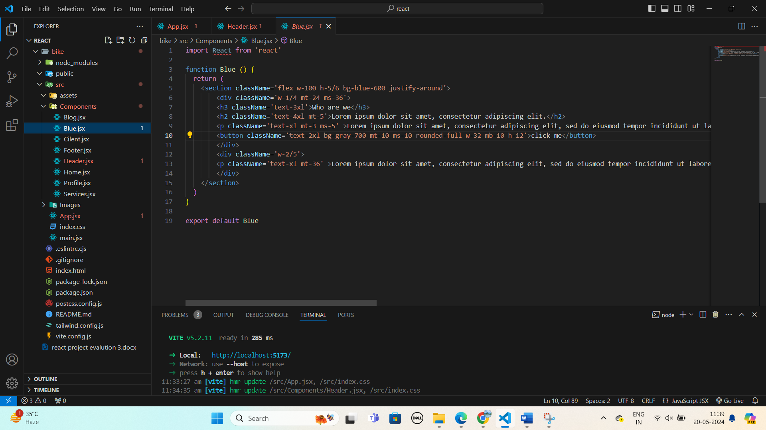

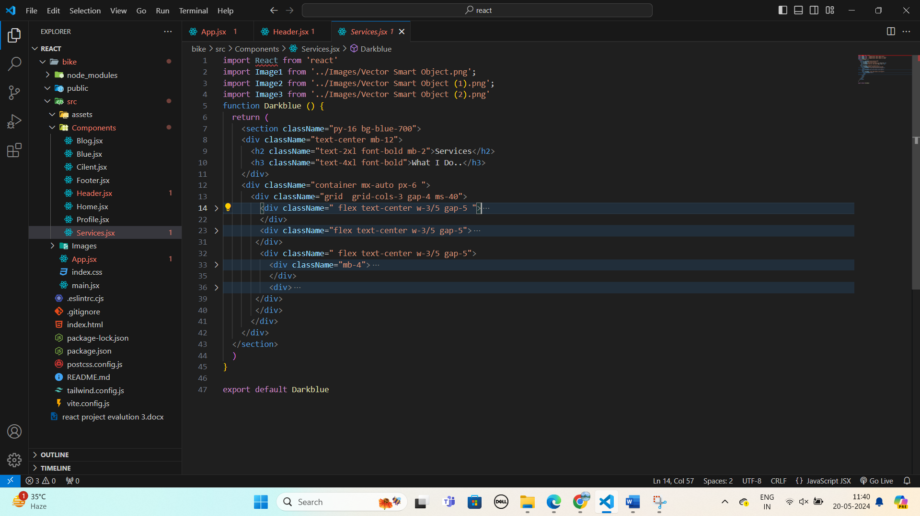

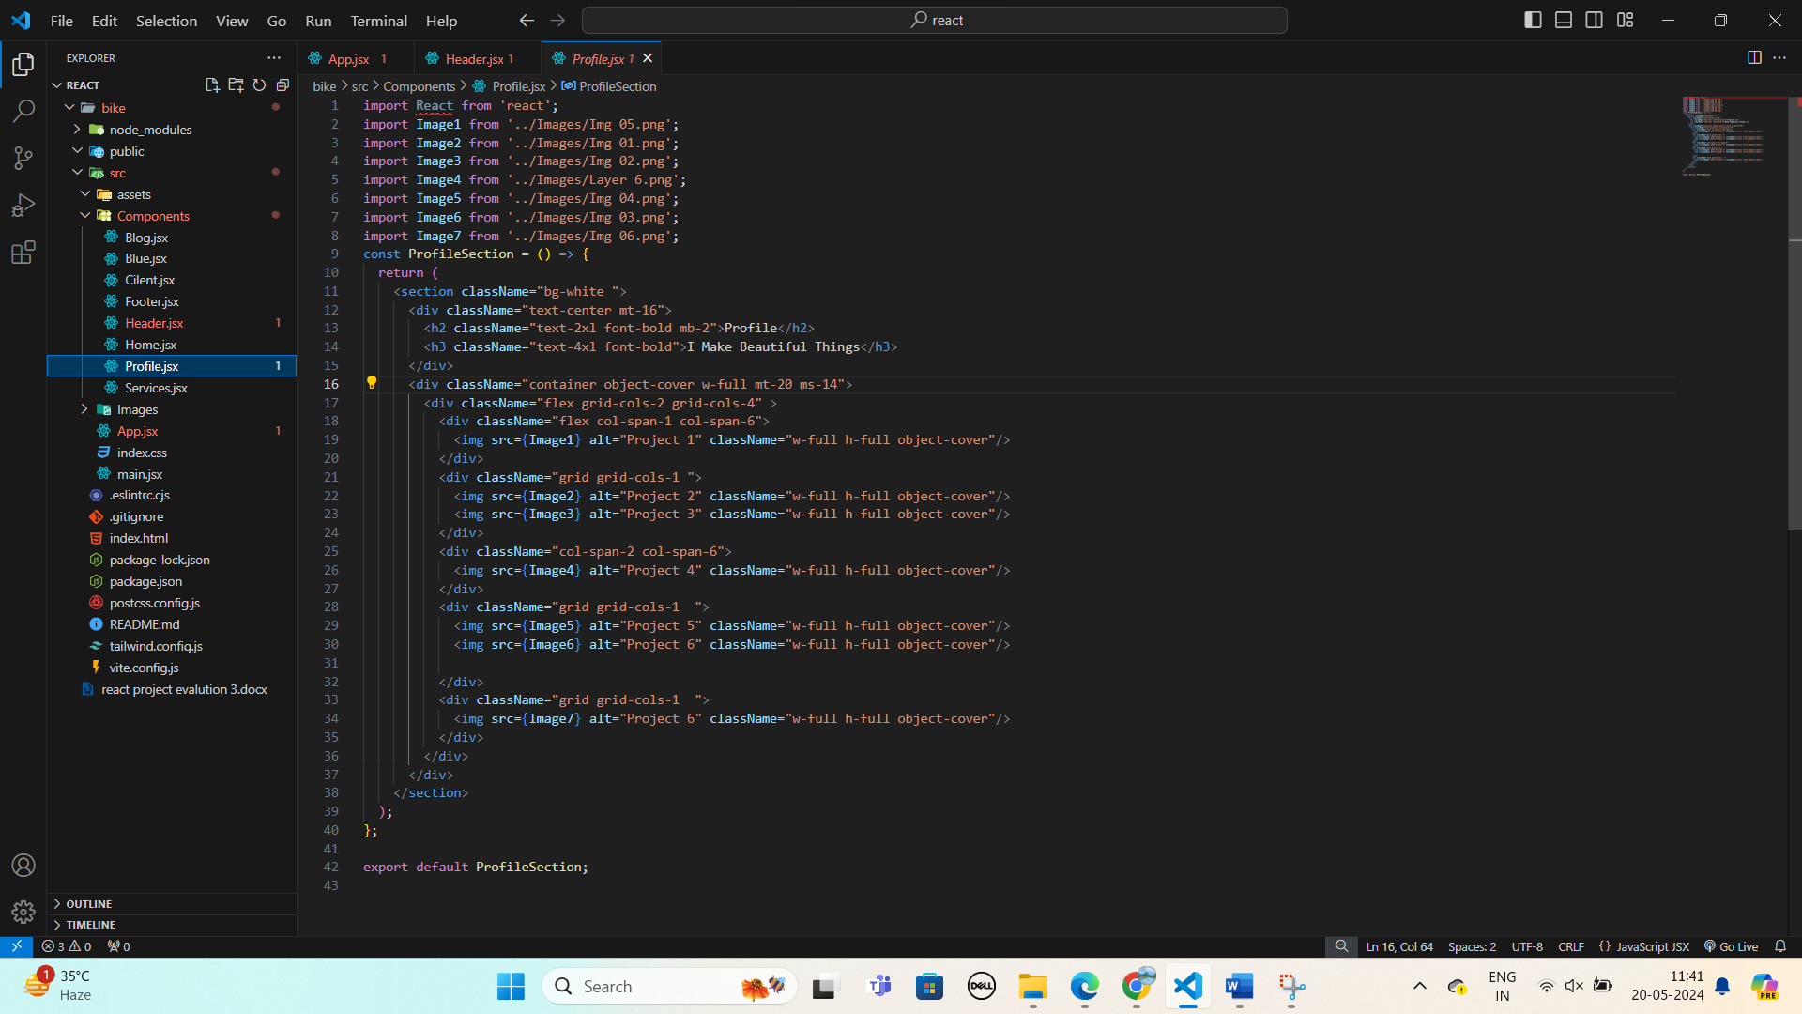

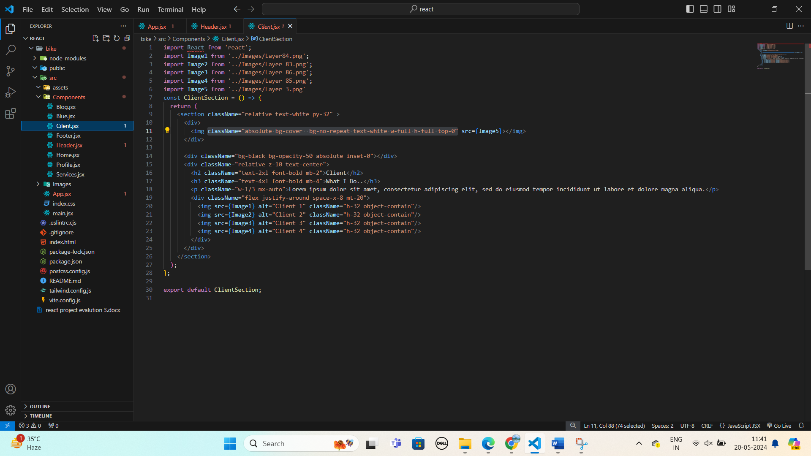

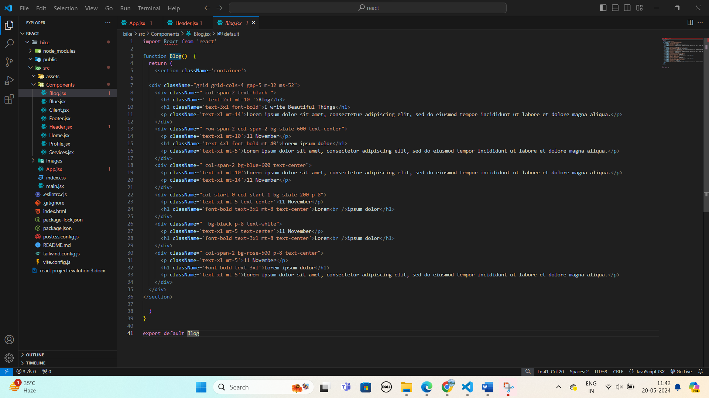

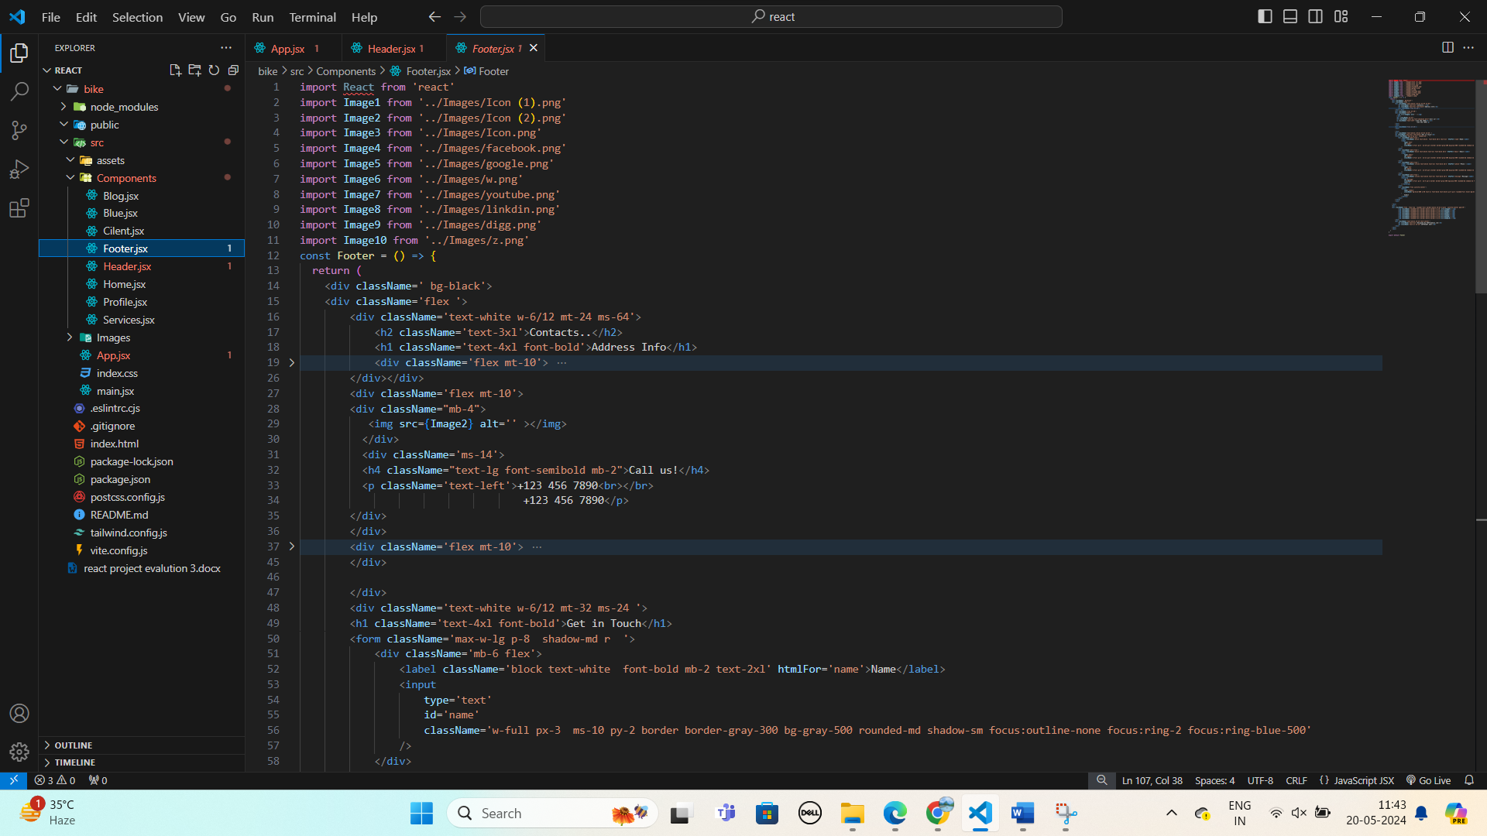

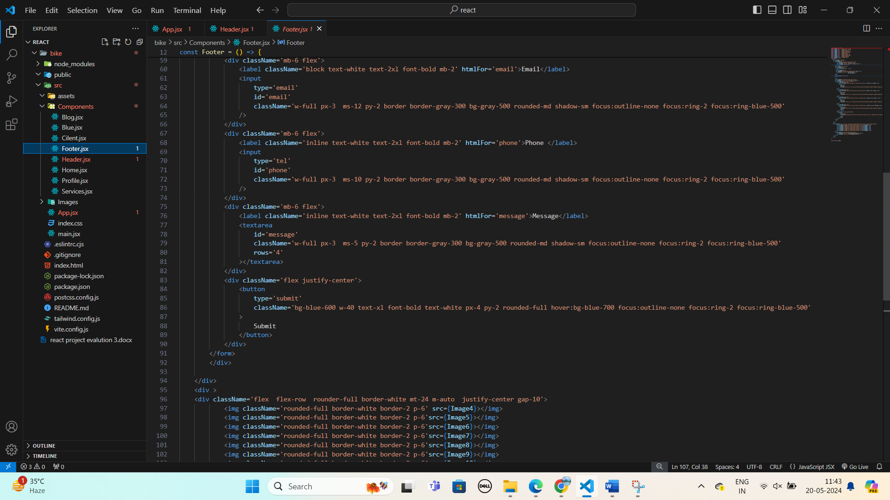

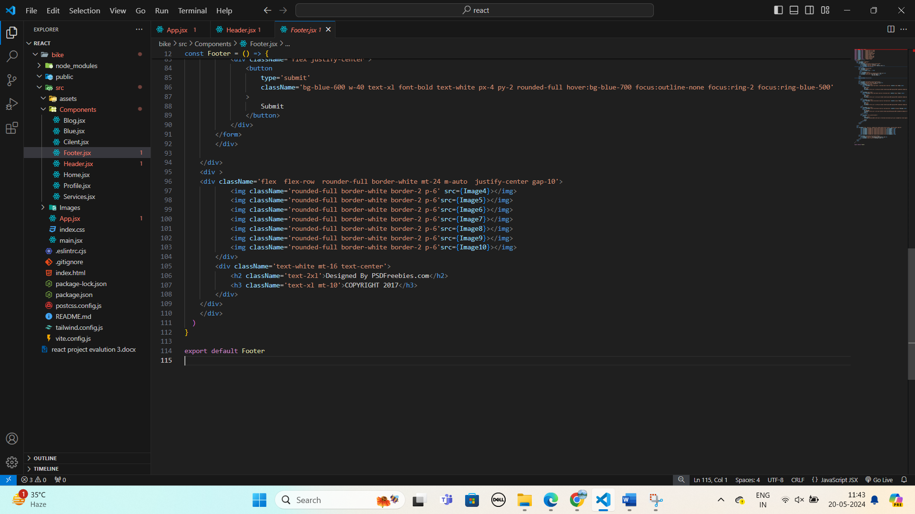

### Conclusion

The project successfully delivered a modern, responsive, and interactive agency template website. Utilizing Tailwind CSS and React provided a robust foundation for rapid development and customization. The final product meets the objectives of showcasing the agency’s services, portfolio, and team in an engaging manner while ensuring a seamless user experience across all devices.

### Result:

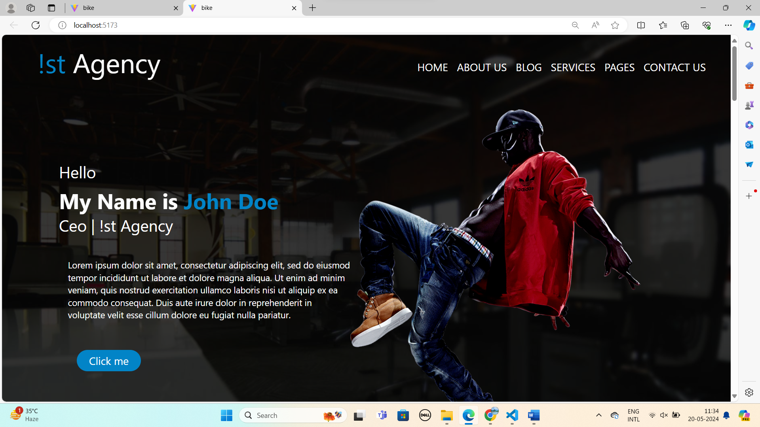

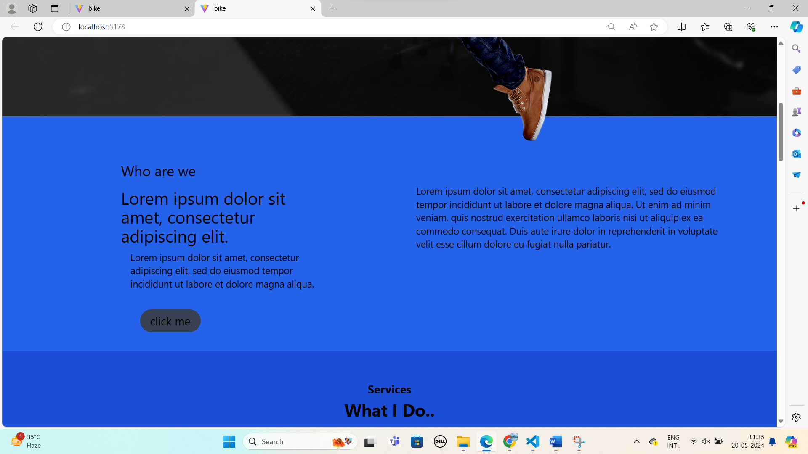

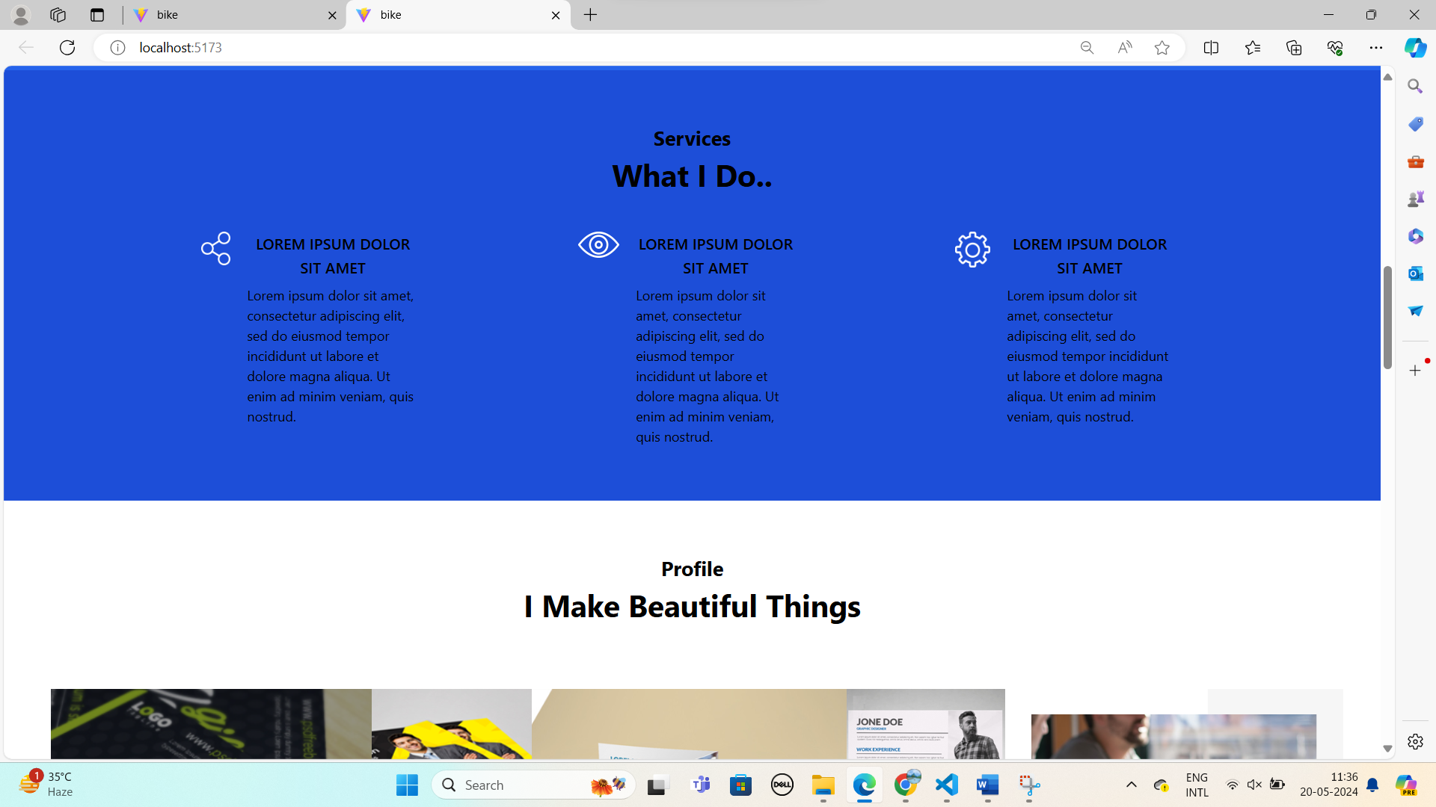

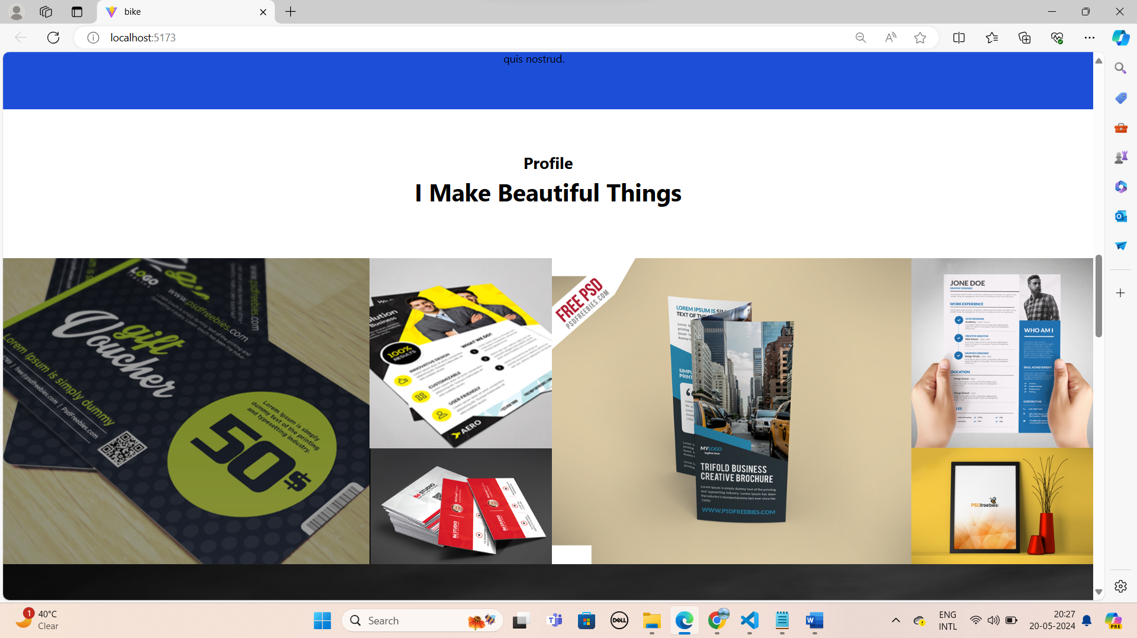

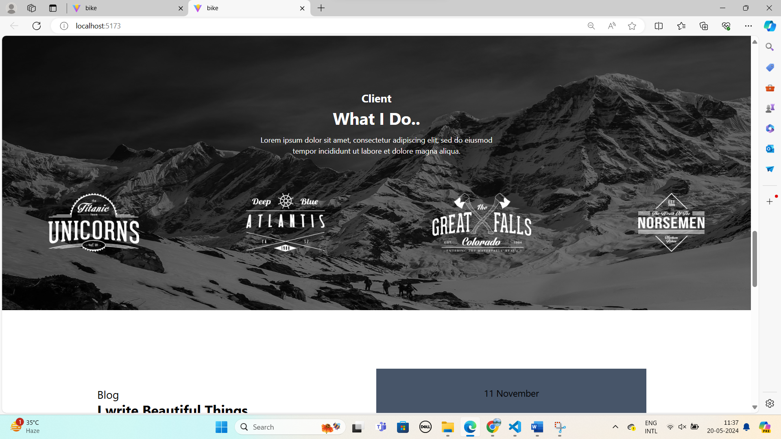

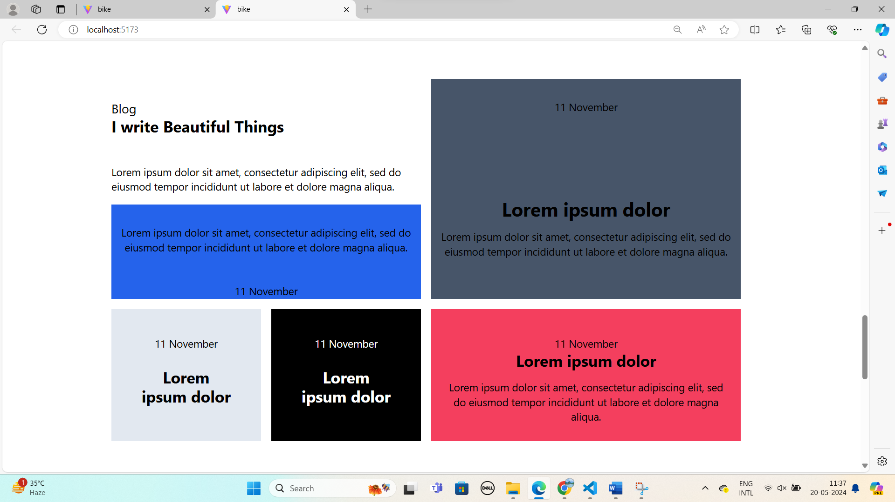

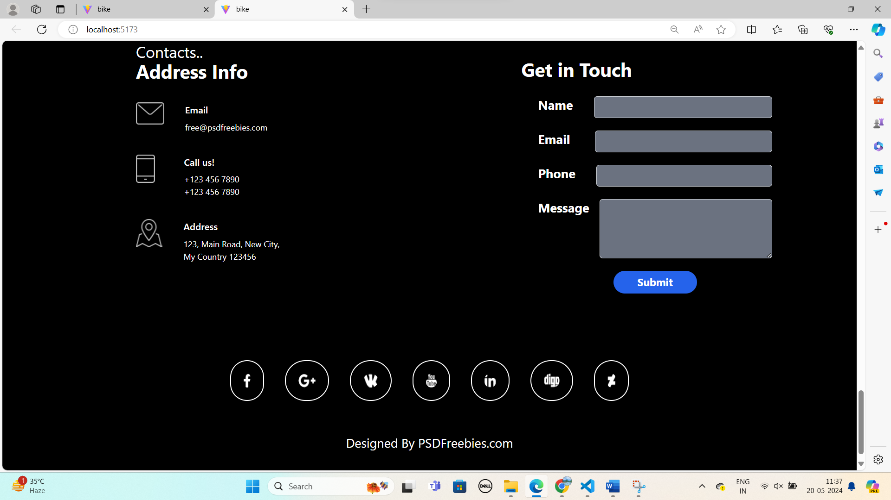

### Future Enhancements

1. **Content Management System (CMS) Integration**: Integrate a CMS for easier content updates.
2. **SEO Optimization**: Implement SEO best practices to improve search engine rankings.
3. **Accessibility Improvements**: Ensure the website meets accessibility standards for a wider audience.
4. **Advanced Animations**: Introduce more advanced animations and transitions to enhance user engagement.

**References:**

* 1. React notes: <https://www.geeksforgeeks.org/reactjs-introduction/>
  2. React: <https://legacy.reactjs.org/docs/implementation-notes.html>
  3. Youtube: <https://www.youtube.com/watch?v=pcUgt8oVsvE&pp=ygUUcmVhY3QgY2hhaSBhdXIgcmVhY3Q%3D>